JOIN US FOR
THE THIRD ANNUAL

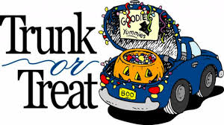

RANDOLPH
UNITED METHODIST CHURCH
PARKING LOT - 3PM TO 5 PM
SATURDAY, OCT. 27TH
In addition to the usual candy treats we will be serving -
HOTDOGS IN BUNS with fixins’
& HOT COCOA
For each of the Little and Big Trunk or Treaters.

SPONSORED BY
RANDOLPH/COURTLAND
UNITED METHODIST CHURCHES
EVERYONE IS WELCOME!!

